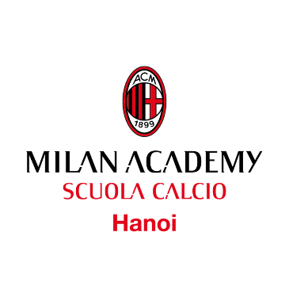
“TALENT WINS GAMES, BUT INTELLIGENCE AND TEAMWORK WINS CHAMPIONSHIPS”
MICHAEL JORDAN

Football is a team sport. The group makes the difference, not a single player alone. To have success, all players must give all themself for the team, respecting others, respecting coaches, rules and the commitment with the team they play with. Nothing great has ever been achieved without dedication and constant application. Follow your dreams, have fun, but take it seriously. Sometimes dreams come true, but only if they are earned, not given. Welcome to A.C. Milan Academy Hanoi.

Players and Teams Rules - Season 2021/2021

1. All Players MUST wear the A.C. Milan Puma Kit during all trainings and matches. If you don’t wear it, the coach has to exclude you from the training session or match.
2. Respect the time table: trainings, for example, start at 17.00 or 19.00. This is the starting time, we suggest you (players) arrive 10 minutes before, to prepare yourself for the session and be ready to start on time. If you arrive late, the coach has to exclude you from the training session or match. It’s about respect of your teammate and the coaches work.
3. Say “Hello” to everyone when you come to the pitch. Greeting is a sign of respect.
4. If you can’t come to the field for trainings or match, you MUST inform the Club no later than 6 hours before the training or match. It’s not acceptable that to inform staff close to the start of training or a match that a player will not be attending. Again, respect your teammate and coaches. If a player fails to arrive on time, you will be excluded from the next training or match.

5. Players who train two times a week, will play matches on the weekends. Players that fail to come to one training without informing staff before or valid reason will play less time during the weekend matches. Players that fail to come to both trainings during the week without informing staff or a valid reason, will be excluded (if the number of the team’s players is big enough) from matches. 6. Players water bottles MUST be in the water battle area before we start the training.
7. Shin pads are mandatory for matches. If you don’t have it, you can’t play. 8. Respect technical stuffs like cones, balls, big cones, goal etc. Our equipment is your equipment.
9. Parents should not speak to their children during training or matches. Mistakes are part of the learning experience: let them try!
10. Say “Good bye” to everyone when you leave the pitch. Greeting is a sign of respect.
11. Be yourself, improve yourself. Football is life: enjoy it!

If you are agreed with these rules, please sign it with today’s date. This document will be valid from signing date until the end of the season 2020/2021.

A.C. Milan Academy Hanoi

FIRSTNAME: SURNAME:

CATEGORY (GROUP):

Date Signature

______________________ ______________________

